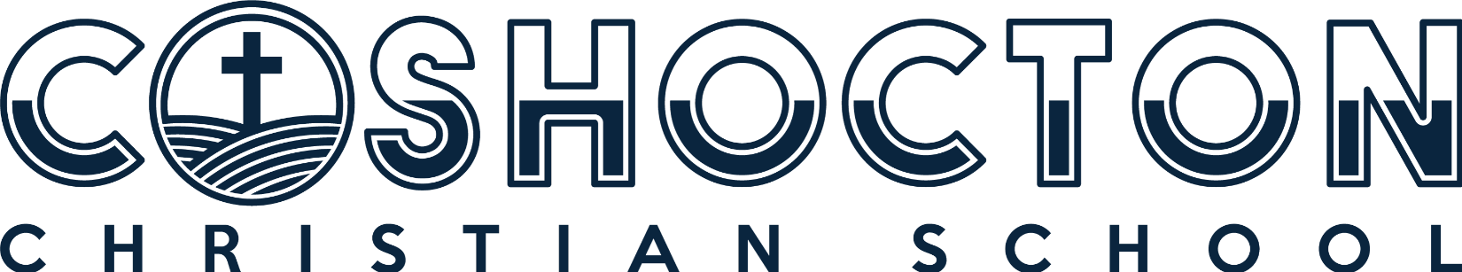

2024-2025 PRESCHOOL SUPPLY LIST

(2) 8 PACK “CRAYOLA” BRAND CRAYONS
(1) 8 CT. WATER COLOR PAINTS
(1) PKG GLUE STICKS
(2) CANS LYSOL SPRAY AEROSOL
(2) PACKS CLOROX WIPES
(1) PACKAGES BABY WIPES
(1) HAND SANITIZER
(1) BACKPACK (Big enough to fit a full-size folder in)
(1) PACK LARGE TICONDEROGA PENCILS
(1) BOX OF PLASTIC SPOONS
(2) PACKS SMALL DIXIE CUPS (plastic only)
- Great Value 5 oz. Bath Plastic cups –or-
- Dixie 9 oz. Plastic cups
(1) BOX QUART OR SANDWICH OR GALLON SIZE ZIP BAGGIES
(4) ROLLS PAPER TOWELS
(2) BOXES OF TISSUE
A CHANGE OF CLOTHING (Labeled in a gallon Ziploc bag)
$60 SNACK FEE
BLANKET FOR NAPTIME (60” X 50” or smaller)
48245 SUITE B, GENESIS DR, COSHOCTON, OH 43812 | (740) 622-5052
CCSADMINOFFICE@GMAIL.COM | WWW.COSHOCTONCHRISTIANSCHOOL.ORG

